Code Determination Number: 010
Date: July 25, 2022
Code Edition: 2021 IBC
Code Section: 907.2.6 Exception 2.
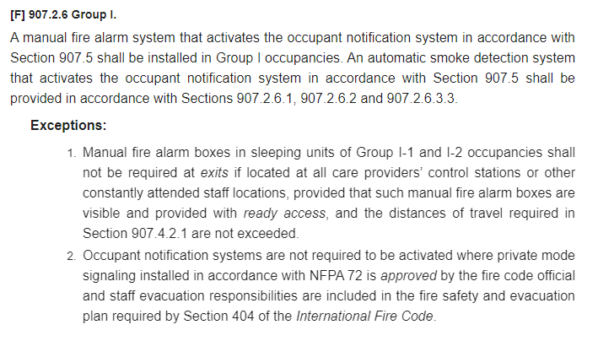

Question (from GBA):
In both sections above, the requirement for automatic smoke detection is clearly stated as a requirement for all areas. However, Exception 2 notes that notification may be waived in certain locations if the system is in Private Mode. Based on communication with design staff at MUHC Hospital, it was stated that there are no known patient rooms that contain either visual or audible notification. This would seem to coordinate well with Exception 2 above. However, this approval is required to be given by the Fire Code Official.
Question: is it to be understood that all areas of MUHC where I-2 Condition 2 occupancies are present shall comply with this exception in the sense that the fire alarm system is on a Private Mode notification (no notification in patient rooms, but alerted at locations such as a Nurse’s Station) while being fully detected (including patient rooms)? I.e. is a standing approval from the AHJ given for Private Mode signaling in I-2 Cond. 2 occupancies?

Answer (from UM System):
Response: field conditions and review of current fire safety/evacuation plans should be included in the review of each project area on a case by case basis. Private mode monitoring should also be confirmed on a case by case basis (based on current manning levels and training of staff- re. current fire safety plan for the facility, compliant with IFC Section 404). The design professional in responsible charge should confirm these conditions with MUHC staff.
Once these measures are verified, yes, IBC 907.2.6, Exception note 2 can be taken. NFPA 72 allows the “notification device” to be located outside the patient room (corridor side), or at the nurses station. Either configuration is acceptable. All patient rooms will require a “detection device” as noted above.
Additionally, MUHC staff can provide designers a copy of the current accreditation documentation denoting private mode monitoring status to include in design back up records.

Applicability: this would apply to Category 1 or 2 patient spaces within an I-1 or I-2 occupancy (critical care, operating rooms, and inpatient bedrooms, dialysis rooms, etc.). Category 3 or 4 patient spaces (exam rooms, medical office, utility room, store room, general support rooms, morgue, etc.) will require standard detection and notification devices, per NFPA 72, unless a variance is approved by the AHJ.

