Code Determination Number: 05
Date: August 21, 2020
Code Edition: 2018 IBC
Code Section: 108.3 Temporary Power
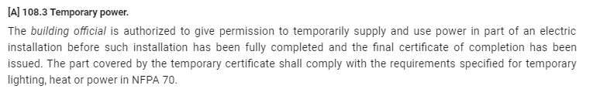

Question (from GBA):
What is the approval procedure for a contractor to obtain approval for temporary power for a project? What types of temporary power installations require a design from the Registered Design Professional in Responsible Charge? What are the duties of the plan reviewer as well as the duties for the code inspector?

Answer (from UM System):
- Temporary power used for construction site trailer(s) and/or temporary pole mounted construction power services should be identified on the project drawings during design. Engineered details for temporary power feeds are not required, unless ratings exceed 200 amps. During inspection: all grounding, conductor sizing, weather protection, equipment environmental ratings, etc., shall apply per NFPA 70.
- Temporary use of installed interior circuits for general lighting and construction power (mobile power panels) are allowed and shall meet the requirements of NFPA 70, article 590 TEMPORARY INSTALLATIONS. Power feeds of this natural shall also be limited to 200 amps, unless engineered.
- Temporary installations where transformer feeders bypass the installed service entrance equipment and are mated to temporary service gear, shall be engineered. The goal is to fully commission the feeders, service entrance equipment and associated sub panels prior to their operational use, whether on a temporary or permanent basis. Other: temporary use of panels and circuits should not impact the warranty start date of this equipment. Temporary breakers are commonly used for construction work, then new breakers are installed when ‘construction’ is complete.

